**HOW TO INSTALL NEXTCLOUD 11.0.1 ON CENTOS 7**

**First of all, install CentOS 7. You must install the minimal version**

root@snet[~]# yum install net-tools -y

root@snet[~]# yum -y update

root@snet[~]# yum -y install nano

root@snet[~]# yum -y install unzip

root@snet[~]# yum -y install wget

root@snet[~]# yum -y install httpd

root@snet[~]# systemctl start httpd

root@snet[~]# systemctl enable httpd

root@snet[~]# rpm -Uvh https://dl.fedoraproject.org/pub/epel/epel-release-latest-7.noarch.rpm

root@snet[~]# rpm -Uvh https://mirror.webtatic.com/yum/el7/webtatic-release.rpm

root@snet[~]# yum install php70w

root@snet[~]# systemctl restart httpd

root@snet[~]# systemctl stop firewalld

root@snet[~]# systemctl disable firewalld

root@snet[~]# nano /etc/sysconfig/selinux

Change "SELINUX=enforcing" to "SELINUX=disabled"

Press CTRL+O then CTRL+X

root@snet[~]# reboot now

root@snet[~]# yum install -y mariadb-server mariadb

root@snet[~]# systemctl start mariadb

root@snet[~]# systemctl enable mariadb

root@snet[~]# mysql_secure_installation

Press enter

Type your desired password

Type your desired password again to confirm

Press enter (4 times)

root@snet[~]# mysql -uroot -p

root@snet[~]# CREATE DATABASE nextcloud;

root@snet[~]# GRANT ALL ON nextcloud.* to 'nextcloud'@'localhost' IDENTIFIED BY 'stephen';

root@snet[~]# FLUSH PRIVILEGES;

root@snet[~]# exit

root@snet[~]# wget https://download.nextcloud.com/server/releases/nextcloud-11.0.1.zip

root@snet[~]# unzip nextcloud-11.0.1.zip -d /var/www/html

root@snet[~]# chown -R apache:apache /var/www/html/nextcloud/

**INSTALLATION OF WEBMIN**

root@snet[~]# wget http://prdownloads.sourceforge.net/webadmin/webmin-1.831-1.noarch.rpm

root@snet[~]# yum -y install perl perl-Net-SSLeay openssl perl-IO-Tty

root@snet[~]# rpm -U webmin-1.831-1.noarch.rpm

root@snet[~]# nano /etc/yum.repos.d/webmin.repo

*Paste the following the container*

[Webmin]  
name=Webmin Distribution Neutral  
#baseurl=http://download.webmin.com/download/yum  
mirrorlist=http://download.webmin.com/download/yum/mirrorlist  
enabled=1

root@snet[~]# wget http://www.webmin.com/jcameron-key.asc

root@snet[~]# rpm --import jcameron-key.asc

root@snet[~]# yum install webmin

root@snet[~]# sudo chkconfig webmin on

root@snet[~]# /etc/init.d/webmin start

**HOW TO AUTOMATICALLY REDIRECT IP TO THE NEXTCLOUD IN APACHE**

root@snet[~]# cd /var/www/html

root@snet[~]# nano index.html

*Paste or type the following code.*

**<meta http-equiv="refresh" content="0; url=/nextcloud" />**

Next, press CTRL+O, press enter, and then press CTRL+X to exit.

**Adding new IP Address when using DHCP**

root@snet[~]# nano /var/www/html/nextcloud/config/config.php

Then add the new IP with ‘192.168.1.1’,

**HOW TO CONFIGURE .HTACCESS FOR MAXIMUM FILE UPLOAD**

root@snet[~]# nano /etc/httpd/conf/httpd.conf

To Configure Apache‘s .htaccess files

Change **'AllowOverride None'** to **'AllowOveride All'**

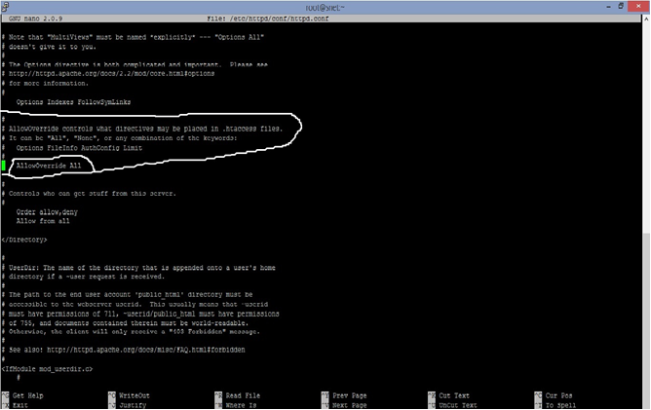

Next, press CTRL+O, press enter, and then press CTRL+X to exit.

Now we need to restart Apache to reload new changes or reboot the server.

root@snet[~]# systemctl start httpd

**TO CHANGE UPLOAD SIZE IN .HTACCESS AFTER CONFIGURED .HTACCESS**

root@snet[~]# nano /var/www/html/nextcloud/.htaccess

Next, press CTRL+O, press enter, and then press CTRL+X to exit.

**Using WinSCP**

root/var/www/html/nextcloud/.htaccess

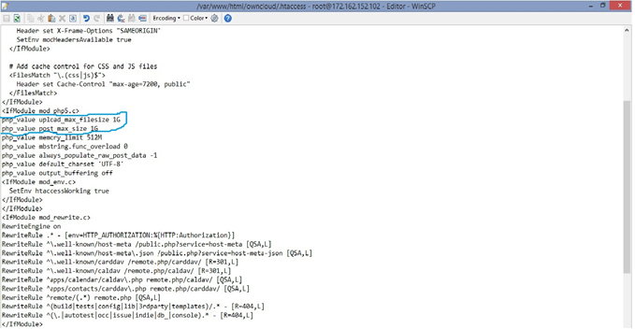

NOTE: The .htaccess will be hiding so press Ctrl+Alt+h.

To change upload size to Gigabyte use 1G not 1GB and in Megabyte use 600M not 600MB

Then save.

**HOW TO INSTALL AND EXTRACT ADDITIONAL APPS**

First install the zip by issue the command below

root@snet[~]# yum install unzip

To direct to a specific directory enter let say apps directory in OwnCloud:

root@snet[~]# cd /var/www/html/nextcloud/apps

Download the file and use WinSCP to upload the file to its directory and extract the file using the following commands below depending the zip file type.

To extract a zip file enter:

root@snet[~]# unzip (file’s name).zip

To extract tar.gz file enter:

root@snet[~]# tar xvfz (file’s name).tar.gz

Exmple:

root@snet[~]# cd /var/www/html/nextcloud/apps/ unzip (file’s name).zip

OR

root@snet[~]# cd /var/www/html/nextcloud/apps/ tar xvfz (file’s name).tar.gz

**BRANDING NEXTCLOUD TO YOUR NAME**

To Brand it to your company’s name and to change Title name go to:

**root@snet[~]#** nano /var/www/html/nextcloud/lib/private/legacy/defaults.php

Next, press CTRL+O, press enter, and then press CTRL+X to exit.

**HOW TO MOVE NEXTCLOUD DATA TO NEW LOCATION**

root@snet[~]# sudo service apache2 stop

root@snet[~]# sudo nano /var/www/nextcloud/config/config.php

Make some changes in the configuration file. Do the following changes

**# 'datadirectory' => '/var/www/html/nextcloud/data',**

To

**'datadirectory' => '/home/sdrive/data',**

root@snet[~]# sudo mv /var/www/html/nextcloud/data /home/sdrive/data

If required change permissions

root@snet[~]# sudo chown -R www-data:www-data /home/sdrive/data

root@snet[~]# sudo service apache2 start

HOW TO ADD NEW DRIVE IN LINUX SERVER

root@snet[~]# sudo fdisk -l

root@snet[~]# sudo fdisk /dev/sdb

Press m

Press n

Press p

Press 1

Choose default

Choose default

Press p

Press w

root@snet[~]# df -h

root@snet[~]# mkfs.ext3 -b 4096 /dev/sdb

root@snet[~]# sudo nano /etc/fstab

Add below to fstab

**/dev/sdb /sdrive ext3 defaults 0 0**

root@snet[~]# cat /etc/fstab

root@snet[~]# mkdir -p /sdrive

root@snet[~]# mount /dev/sdb /sdrive

root@snet[~]# df –h

**HOW TO UPDATE OR UPGRADE NEXTCLOUD**

**NOTE:** Before you do this make sure your server is connected to the internet

**1**. Backup **Config folder** and **Data folder** located at /**var/www/html/nextcloud directory** using WinSCP or FileZilla

**2**. Stop apache and mysql using the below commands

**How to Stop Apache**

root@snet[~]# systemctl stop httpd

**How to Stop MySQL**

root@snet[~]# systemctl stop mariadb

**3**. Delete nextcloud folder from the /**var/www/html directory** using WinSCP or FileZilla.

4. Download the latest version of nextcloud from their website and upload it using WinSCP or FileZilla to /**var/www/html directory**

**5.** Extract the owncloud zip folder at /**var/www/html directory**

root@snet[~]# unzip nextcloud-x-x-x.zip **OR**

root@snet[~]# tar -xjf nextcloud-x.x.x.tar.bz2

**6.** Upload the **config folder** and **data folder** that was backup using WinSCP or FileZilla and grant the permission with the command using putty

root@snet[~]# chown -R apache:apache /var/www/html/nextcloud/

**OR**

root@snet[~]html# chown -R apache.apache nextcloud

**7.** Then start apache and mysql using the below commands

**How to Start Apache**

root@snet[~]#systemctl start httpd

**How to Start MySQL**

root@snet[~]# systemctl restart mariadb

**8.** Finally complete your update or grade using web browser. Enter your server’s name or IP slash nextcloud

<http://your-server> IP/nextcloud or http://yourservername/owncloud

***By Stephen Fosu***